**A Reflection Upon a Summer Abroad**

Jay Shen

I do not wish to dilute the words I have for my seventy days abroad, but they were nothing short of incredible, dream-like, unforgettable. I learned more—about a foreign country and its people, about my own country and its people, about globalization and locality, about change—than I have from any other single experience in my life. The people I met, the places I went, and the things I did—they will always occupy a warm place in my memory. I hope I can revisit them soon.

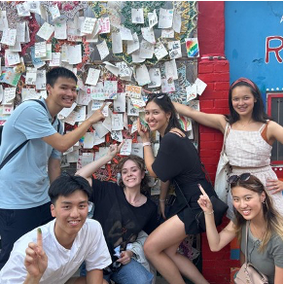

*The UChicago-Taiwan Student Exchange Program*

I'll admit that, at first, Taipei disappointed me. In part, this was a case of expectations. Last

winter I traveled across China, which impressed me with its sheer power, wealth, and enormous velocity towards modernity. In some shallow way, it fascinated me, and I wanted in on it. But Taipei, in appearance, was not quite that gleaming Eastern city, visibly ripe with economy, that I had admired, envied, and sought to know. The boxy and water-stained buildings appeared to me ugly and ramshackle; the reliance on cash was rudimentary and inconvenient; the offices and facilities where I worked were cramped and messy. It didn't help that I spent the morning I arrived in Taipei wandering the backstreets of Datong—lost, sweaty, confused.

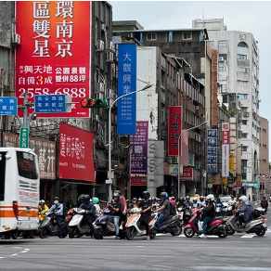

*Initial impressions of Taipei*

However, working and living in Taipei, interacting with the city and its people at a low level, allowed me to scratch past that surface. Beneath that urban facade was an air of tolerance and practicality, the breath of a deeply honest society both kind to itself and kind to others. This ethos soon began to manifest itself before me, taking the form of a million of microcosms embodying the Taiwanese spirit I've grown to admire—the industriously altruistic helpfulness; the mercilessly self-deprecating humor at once frivolous yet penetrative; the amused patience with my profound illiteracy and subpar Mandarin; the infectious politeness.

*Taiwanese Friends*

This good nature, however, betrayed no softness, complacency, or conformity of any kind. On the contrary, the Taiwanese I had the pleasure of knowing were tough, ambitious realists proud of their individuality and confident in their own agency. They were eclectically cosmopolitan and—perhaps owing their geopolitical vulnerability—keenly conscious of change and mobility. Among them I met rappers-turned-physicists, high-school dropouts become business professors, and ex-BCG gangster-philosophers. There were no molds that fit them, least of all those fashioned by Western perceptions. They greatly impressed me in all regards, and deeply challenged my perceptions of how people can differ, and remain alike, across borders. We bonded over things big and small, and forged relationships that will always and forever be the most cherished souvenirs I take from Taiwan.

*More Taiwanese Friends*

I've since returned home to Los Angeles, and I feel sad that my time in Taiwan is over—I miss it already. But I feel a deep gratitude, the type that can only be inspired by drastic change, the type that shakes you out of your comfort, makes you pause, and look around. I'll miss the city of Taipei, its dense, cozy convenience; but for now, I am grateful for the airy openness of my quiet hometown. I'll miss getting paid to travel, learn, and do fascinating research all at the same time; but for now, I am grateful that more learning awaits me come the school year. I'll miss the affordable, delicious Asian food in Gōngguǎn and on Avenue 118; but for now, I am grateful for zingy Mexican food and greasy five-dollar burgers. I'll miss the lush tropical beauty of Taiwan and its warm, blue seas; but for now, I am grateful for the sparse, southwestern country and the cool California surf. More than anything, I'll miss all the friends I made in Taiwan, dearly; but for now, I am grateful for old, familiar friends back home. I probably won't miss the humidity, the heat, and the sweat, however; and for that, I'm grateful for the dry Santa Ana winds and the salty ocean breeze.

*Leaving Taiwan...*

Thank you, everyone, for an unforgettable summer.